***x

**Autumn 2022 Edition (September-November)**

Welcome to our newsletter. The aim of the of our newsletter is to keep the community up to date with current guidance and health related events our community can become involved in. If there is a particular topic area or information you would like to see in our next newsletter, please pass this onto one of our PPG members or feel free to join our next PPG meeting. Your opinions are important to us.

**Edzell Health Centre Newsletter**



**Patient Participation Group (PPG)**

**If you answered yes, come join our PPG.**

The PPG is a group of active patient volunteers who work with practice staff to voice concerns and provide a patient perspective on the services provided. **Meetings are quarterly, held at the practice. Ask at reception for details of the next meeting**

Interested in health awareness?

Would you like your voice heard?

Want to make a difference?





**World Alzheimer’s Month is September and worlds Alzheimers day takes place on**

**Wednesday 21st September**

* This years theme is the power of knowledge
* During Alzheimer month the aim is to raise awareness of the signs and symptoms of dementia
* Education and awareness allows the right diagnoses and support to be put in place
* Dementia is one of the biggest challenges faced globally with nearly 50million people living with it
* To learn more about dementia you can visit Alzheimer’s society website

**What are we doing?**

* The staff at Edzell Health Centre are doing ‘walk 30 miles in September for dementia’ to raise funds and awareness
* For information, updates or if you would like to donate, please visit our facebook page and website

**Seasonal Flu and Covid19 Booster Vaccinations**

* You will receive a letter in the post with an appointment for your vaccination
* If you cannot attend your appointment please follow the instructions on the letter or visit NHS inform to reschedule
* Vaccinations will NOT take place at Edzell Health Centre but in a central vaccination hub
* The Covid19 vaccination should only be given after a minimum of 12 weeks have past
* Only one dose of the winter flu vaccine is needed
* Please wait until you are contacted



**Prescriptions**

* Please order your medication 1 week before running out
* Prescription request can NOT be accepted over the telephone
* We encourage all our patients to

sign up to use our **online services** by providing reception staff with an up-to-date email address.

* Once registered, you will be able to **request your prescriptions remotely**.
* This saves you time and reduces paper waste
* Prescription requests arriving at Edzell Health Centre are processed within 48hours
* They are then sent to your preferred pharmacy (option to collect from health centre if marked to us)
* Pharmacy then dispense your medication within 2 working days

**Pharmacy First Scotland**

* NHS Pharmacy First allows community pharmacy teams to offer advice, treatment or referrals to other healthcare teams where required.
* They can help individuals with conditions such as sore throats, earache, cold sores & common conditions such as urinary tract infections (UTI).
* Without the need to wait to see their GP or attend their local accident & emergency department for non-urgent treatment.

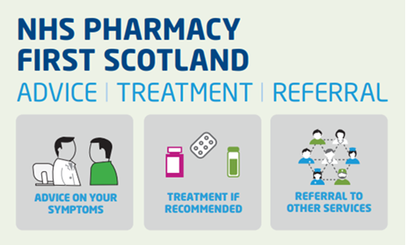

0

**Clinics and Services**

* Coil/Implant fitting: Carried out by Family Services, Ninewells – 01382 425 542
* Cervical Smears : Carried out in practice – appointments can be arranged after you receive your letter in the post. Females aged 25-49 normally have 3 yearly tests and females aged 50-64 every 5 years
* Ante-Natal Clinic: New pregnancies are co-ordinated by midwives – 01241 822 537
* Wart/Liquid nitrogen clinic: Carried out in practice - Held monthly on a Monday by appointment
* Volunteer Transport Service is running: Please contact the practice to request this service (allow as much notice as possible)

**Reducing our Carbon Footprint** 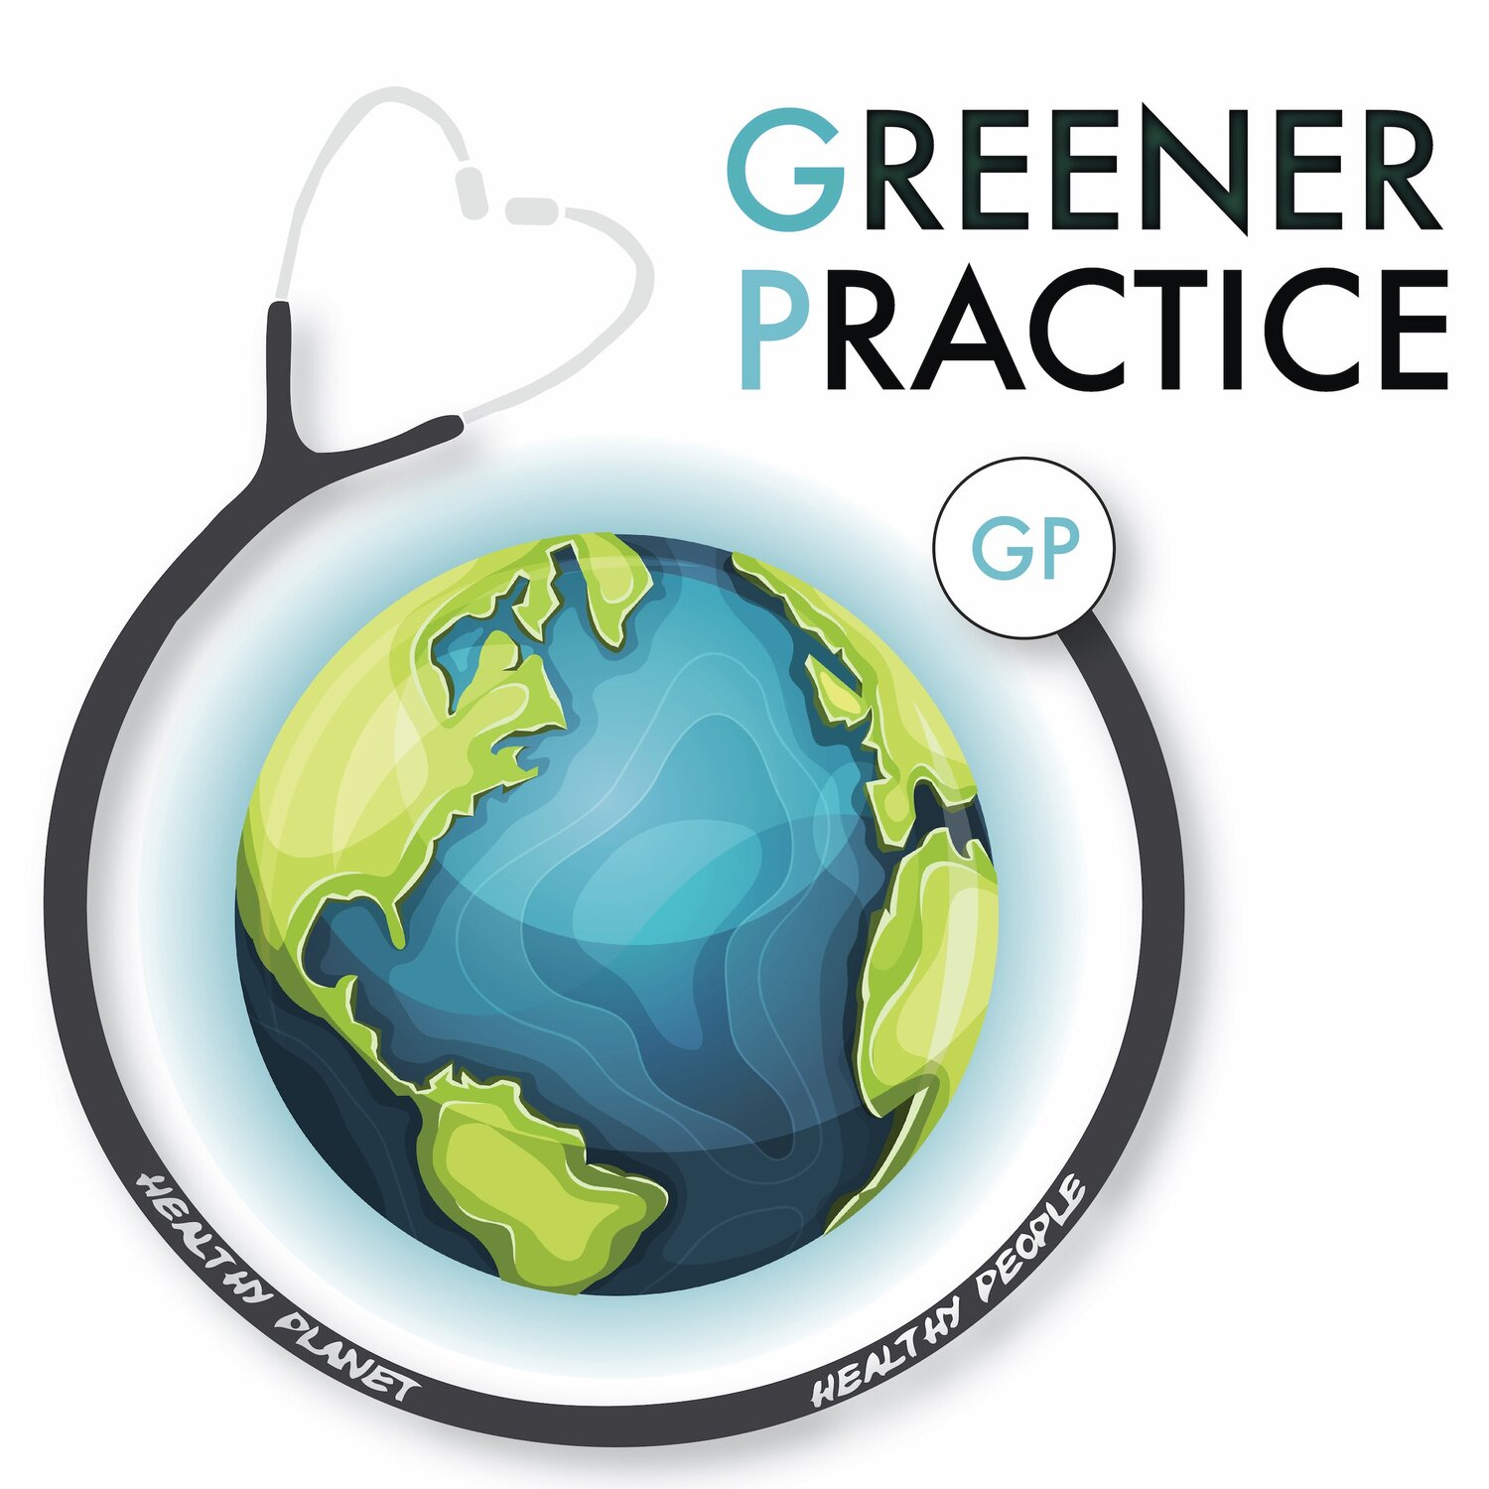 We aim do our best to reduce our carbon footprint. Working together with staff & patients we feel as a team, we can make an impact through small lifestyle changes. Examples include recycling, reducing waste via utilisation of online services, switching off unused appliances & active travel.

**Practice Updates**

**Public holiday closure**

Monday 10th October 2022

**Member of staff leaving**

Our receptionist Kay Potter is retiring after 38 years of loyal service to Edzell Community on Friday 9th September. We wish her a happy retirement

**Appointments**

* All new appointments will be telephone calls initially
* The receptionist will ask for brief details of your call, this enables them to direct you to the most appropriate service.
* Once reviewed by the doctor you may be asked to attend a face-to-face appointment if required.
* Our phone lines may be busier than usual, so we urge the public to remain patient and remember that your call is important to us. We will get to you as soon as we can.
* **If you feel your reason for calling is an emergency and cannot wait, please hang up and call 999.**

**Edzell Health Centre** High Street**,** Edzell, DD9 7TA **Phone**: 01356 648 209 **Email**: [edzellhealthcentre.tayside@nhs.scot](mailto:edzellhealthcentre.tayside@nhs.scot)

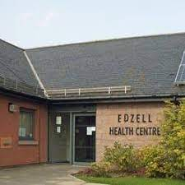

**Pharmacy First Scotland**

* NHS Pharmacy First allows community pharmacy teams to offer advice, treatment or referrals to other healthcare teams where required.
* They can help individuals with conditions such as sore throats, earache, cold sores & common conditions such as urinary tract infections (UTI).
* This helps to ensure people are accessing **the right care in the right place,** without the need to wait to see their GP or attend their local accident & emergency department for non-urgent treatment.

**Pharmacy First Scotland**

* NHS Pharmacy First allows community pharmacy teams to offer advice, treatment or referrals to other healthcare teams where required.
* They can help individuals with conditions such as sore throats, earache, cold sores & common conditions such as urinary tract infections (UTI).
* This helps to ensure people are accessing **the right care in the right place,** without the need to wait to see their GP or attend their local accident & emergency department for non-urgent treatment.